|  |  |
| --- | --- |
| |  | | --- | | Vol 15, Issue 2, (2025) E-ISSN: 2222-6990 | |

**Enhancing the Sustainability of Waqf: A Thematic Review Exploration Across Financial, Social, and Environmental, Governance Dimensions**

Baharin. Na, Siraj. S.Ab, Osman@Husin. A.Zc, Mohd Ariffin. Nd

a,b,c,dDepartment of Accounting, Kulliyyah of Economics and Management Sciences, International Islamic University Malaysia,53100 Gombak, Selangor, Malaysia

Corresponding Authors Email: baharinbahriah@gmail.com

|  |
| --- |
| **To Link this Article:** http://dx.doi.org/10.6007/IJARBSS/v15-i2/24854 DOI:10.6007/IJARBSS/v15-i2/24854 |
| ***Published Date:*** 25 February 2025 |

**Abstract**

Waqf, a cornerstone of Islamic philanthropy, has historically contributed to socio-economic and environmental sustainability. Despite its significant potential, waqf institutions face limited governance frameworks, outdated practices, and insufficient integration with contemporary financial and technological systems. These gaps hinder its alignment with modern sustainability objectives, particularly in addressing economic, social, environmental, and governance-related issues. This study explores and enhances waqf’s sustainability through a thematic review encompassing five key areas: financial sustainability and economic development, community empowerment and social welfare, innovative waqf models and practices, environmental sustainability, and governance and legal frameworks. This study employed a structured thematic analysis and synthesised findings from recent literature published between 2018 and 2024. The results reveal that waqf’s potential can be maximised through innovative financial models, community-driven initiatives, green strategies, and robust governance mechanisms. Contributions include cash waqf integration with microfinance, productive waqf initiatives in education and agriculture, and adopting governance frameworks that align with sustainable development goals. These findings demonstrate waqf's adaptability to modern challenges, showcasing its role in promoting financial inclusion, community resilience, and ecological conservation. Future research should focus on digitalising waqf management, exploring interdisciplinary approaches, and scaling innovative models across diverse socio-economic landscapes. The study contributes to academia by filling gaps in waqf-related sustainability research. It offers practitioners actionable strategies for optimising waqf’s impact, positioning it as a vital tool for achieving comprehensive sustainability in a rapidly evolving global context.

**Keywords:** Waqf, Sustainability, Waqf Practices, Sustaining of Waqf, Thematic Review

**Introduction**

The waqf institution has been a pillar of Islamic philanthropy for centuries, promoting social welfare, economic stability, and sustainable development worldwide and beyond. Historically, waqf played a significant role during the golden age of Islam, shaping modern endowment systems, including those in European educational institutions (Bulut, 2020). This historical legacy underscores waqf's transformative potential, which remains crucial in addressing contemporary challenges. However, in recent decades, the waqf system has faced challenges such as outdated governance structures, limited human capital development, and a lack of innovative financial mechanisms, compromising its long-term viability and highlighting the need for urgent reform (Yuspin & Fauzie, 2018).

Recent trends in research and practice has highlighted a growing recognition of waqf's potential in addressing modern challenges. Innovations such as collaborations with microfinance initiatives have enhanced their relevance by meeting urgent community needs and promoting socio-economic growth (Ibrahim, 2021). Similarly, academic works have emphasised aligning waqf with the Sustainable Development Goals (SDGs), particularly in poverty alleviation and environmental sustainability (Awaludin et al., 2018). Nevertheless, significant gaps persist, including the limited exploration of innovative financial mechanisms and a lack of robust frameworks connecting waqf with long-term sustainability goals.

This study addresses these gaps by conducting a thematic review of waqf sustainability, focusing on enhancing its viability through innovative strategies and governance reforms. By synthesising insights from both practitioners and academics, the study aims to bridge existing knowledge deficits and propose actionable strategies to revitalise waqf, ensuring its alignment with sustainability goals. Specifically, this article aims to conduct a thematic review of published discussions on enhancing waqf sustainability from 2018 to 2024, guided by the research question outlined below.

RQ: What are the current trends in WAQF and sustainability publications found in the literature from 2018- 2024?

**Materials and Methods**

According to Clarke and Braun (2013), thematic analysis is a process that involves identifying patterns within qualitative data and constructing pertinent themes that emerge from an in-depth examination of the subject matter. The concept of a "thematic review" was employed within the framework of this study, utilising ATLAS.ti as the primary analytical tool. This methodology was initially introduced by Zairul (2021b, 2021a), Zairul et al. (2023) and Zairul & Zairul (2020), who hold copyright protection with registration number CRLY2023W02032. The TreZ is incorporated into the analysis because it aligns with the systematic thematic analysis procedures necessary for conducting a thorough literature review. (Zairul, 2023). This meticulous approach allows the researcher to synthesise insights and draw meaningful conclusions from the literature reviewed.

Figure 1: Thematic Review FlowZ (TreZ)

The process began with formulating the research question: "What are the current trends in sustainability within Waqf, as discussed from 2018 to 2024?" This question served as a roadmap for the subsequent stages of the review, clearly establishing both the focus and scope. The next step, article screening (Screen) (see Table 1), involved identifying and selecting studies based on their relevance to the research question. This was followed by the article filtering stage (Filter) (refer to Figure 2), during which inclusion and exclusion criteria were applied to refine the selection further, ensuring that only the most pertinent articles were retained for analysis. The fourth step, cleaning (Finalise) (illustrated in Figure X), entailed a thorough review of the articles' metadata to confirm the accuracy and completeness of the data. Finally, the last step involved data extraction (Synthesis) (Figure X), where a thematic analysis is conducted using tools such as ATLAS.ti. This analysis aims to develop themes through extensive reading of the subject matter in the selected articles. This structured approach enhances the reliability and depth of the review, ensuring a comprehensive analysis of the literature.

Table 1

*Search Strings from Scopus and WoS*

|  |  |  |
| --- | --- | --- |
| **SCOPUS** | Advanced Query  ( TITLE-ABS-KEY ( waqf ) AND TITLE-ABS-KEY ( sustainability ) ) AND PUBYEAR > 2018 AND PUBYEAR < 2024 AND ( LIMIT-TO ( DOCTYPE , "ar" ) ) AND ( LIMIT-TO ( OA , "all" ) ) AND ( LIMIT-TO ( PUBSTAGE , "final" ) ) AND ( LIMIT-TO ( LANGUAGE , "English" ) ) AND ( LIMIT-TO ( SRCTYPE , "j" ) ) | **26 results** |
| **Web of Science (WoS)** | Refine results for waqf (All Fields) AND sustainability (All Fields) and Open Access and 2018 or 2019 or 2020 or 2021 or 2022 or 2023 or 2024 (Publication Years) and English (Languages) and All Open Access (Open Access) and Article (Document Types) and English (Languages) and All Open Access (Open Access) | **21 results** |

The next step involves identifying patterns and establishing categories to better understand the trends related to waqf and sustainability, as highlighted in the literature from 2018 to 2024. This research phase aims to analyse and interpret the findings to develop recommendations for future studies in waqf sustainability. Adopting this approach is essential in clarifying how these trends have evolved over time and in pinpointing new directions or innovations that could be vital for future advancements in these areas. To ensure a thorough and relevant analysis, the selection of literature for this review was guided by specific criteria: 1) a publication date range from 2018 to 2024, ensuring the research remains current and significant; 2) the inclusion of key terms such as 'Waqf' and 'Sustainability' in the literature, which focuses on studies directly pertinent to the core themes of this research. This systematic selection process aids in capturing a wide array of contemporary insights and developments in these fields.

The literature review was conducted by searching two major academic databases, SCOPUS and Web of Science, selected for their extensive coverage of peer-reviewed journals relevant to waqf and sustainability. In SCOPUS, the search was conducted using the keywords "waqf" and "sustainability" in the title, abstract, and keywords **(TITLE-ABS-KEY)**, targeting publications released between 2018 and 2024. The search was restricted to academic articles in English that were open access **(LIMIT-TO (DOCTYPE, "ar"), LIMIT-TO (LANGUAGE, "English"), LIMIT-TO (OA, "all")).** This strategy identified 26 articles, indicating a substantial body of recent literature. In contrast, the Web of Science search was broader, using the exact keywords across all fields without specific restrictions and focusing solely on open-access articles in English. This approach yielded 21 results. The discrepancy in the number of articles retrieved from each database reflects differences in indexing depth, journal coverage, and the specifics of their search algorithms, providing a diverse array of articles for the review.

In the context of a thematic review employing specific search strings, this research carefully outlined and implemented a selection process to identify relevant literature from two prominent academic databases, SCOPUS and Web of Science (WoS). The researchers have detailed the methodological steps taken in this study, ensuring a rigorous selection of studies validity and reliability of our review findings (see Table 1)

Record identified through Scopus database

**n=26**

Record identified through WoS database

**n=21**

Studies not eligible according to inclusion and exclusion

**n=4**

Duplication Removed

**n=9**

**Studies Included**

**(n=34)**

Figure 2: Inclusion and Exclusion criteria in TreZ (Zairul, 2023)

The research commenced with carefully developing crafted queries specifically designed to align with the research objectives. These targeted queries were employed across two prominent academic databases, SCOPUS and Web of Science. Through this comprehensive approach, the researchers were able to uncover 26 records from SCOPUS and 21 records from Web of Science. The initial search results yielded a wide-ranging collection of literature, encompassing various aspects relevant to the topic of interest.

Upon merging the findings from both databases, the researchers undertook the critical task of identifying and eliminating duplicate entries to ensure the integrity and uniqueness of each record for subsequent evaluations. During this meticulous process, a total of nine duplicate records were recognised and excluded from the overall dataset. A rigorous screening phase followed, where the consolidated list of records was assessed against a set of meticulously crafted inclusion and exclusion criteria. These criteria were developed with a keen focus on the research questions and goals, ensuring high relevance to the subject matter. The thorough screening uncovered records with a value of four (“4”) —indicating they did not meet the established criteria and should be discarded. This was done to ensure that only the most pertinent studies were retained for further analysis.

In total, 34 studies that meet the comprehensive eligibility requirements at the outset were selected for the systematic review. These studies were anticipated to offer significant insights that directly address the research questions. As outlined, the systematic and thorough approach to the study selection process underscores the diligence and rigour necessary for conducting a complete and reliable review. By meticulously sifting through the literature, the researchers aimed to minimise biases and enhance the credibility of the conclusions drawn from the review. This report is a foundational element of the review paper, providing essential clarity and transparency regarding the methods employed in the study selection process. This aspect is also vital for ensuring the replicability of the findings and fostering trust among readers (see Figure 2).

**Results and Discussions**

This thematic review (TreZ) presents a comprehensive five-year overview (2018–2024) of studies on waqf and sustainability. The selected studies underscore the critical role of waqf in socio-economic development, highlighting its significant impact on economic, social, and environmental dimensions. Waqf's contributions are central to achieving the Sustainable Development Goals (SDGs), particularly in eradicating poverty and fostering equitable wealth distribution. However, ensuring the sustainability of waqf requires innovative models, enhanced practices, and strengthened governance to optimise financial, social, and environmental outcomes.

The findings reveal that waqf can be a powerful tool for sustainable development when integrated with modern management practices and technologies. For instance, the Green Waqf model aligns waqf activities with SDG objectives, such as preserving terrestrial ecosystems, addressing environmental challenges, and promoting sustainability (Anas et al., 2020; Rusydiana et al., 2023). Similarly, initiatives like agroforestry in waqf forests in Indonesia illustrate how waqf can enhance biodiversity and forest health while delivering social and economic benefits (Jannah et al., 2021).In addition, the integration of technology and innovative governance models, such as the Waqf Integrated Income Generating Model (WIIGM), has demonstrated the potential to generate sustainable income and strengthen public trust in waqf institutions (S. S. Ibrahim et al., 2022; S. S. B. Ibrahim et al., 2019). Despite these advancements, significant challenges persist. Governance, transparency, and standardisation of waqf management practices remain critical issues that must be addressed to fully realise waqf's potential in advancing sustainable development (Yunus et al., 2024).

This article delves into these themes, analysing the current state of waqf sustainability, the obstacles encountered, and the innovative approaches being explored to enhance waqf's role in sustainable development. By addressing these issues, waqf institutions can better fulfil their traditional roles while meeting contemporary economic, social, and environmental sustainability needs. The review enriches the existing body of literature by offering valuable insights into the practical implementation of waqf and its alignment with sustainability goals. It highlights key areas where waqf can substantially contribute to economic, social, and environmental sustainability. Furthermore, the findings integrate quantitative analysis to address the first research question and qualitative evaluation to explore the second, providing a well-rounded perspective on the trends and developments in waqf sustainability research from 2018 to 2024.

What are the current trends in WAQF and sustainability publications found in the literature from 2018- 2024?

*Quantitative Reporting*

The 34 data show a steady academic interest in waqf sustainability from 2018 to 2023, with notable peaks in 2019 and 2020, each with seven publications. These peaks suggest a growing focus on waqf as a critical economic and social development area. Topics such as financial sustainability (Nik Ahmad et al., 2019; Sulaiman et al., 2019), governance (Awaludin et al., 2018), and the role of waqf in supporting education and community welfare (Johari et al., 2023) are featured prominently in the dataset. However, the drop to only one publication in 2024 could reflect an incomplete dataset for the year or a shift in research priorities. It is also evident that the studies are diverse, ranging from cash waqf models to integrated approaches linking waqf with other social finance tools.

Figure 3: Paper breakdown according to the year of publication

This trend points to both opportunities and gaps in the literature. While considerable work is on models and frameworks for sustaining waqf, areas such as using technology in waqf management or its application in addressing modern challenges, like environmental protection(Jannah et al., 2021), need to be explored. Additionally, many studies focus on Malaysia and Indonesia, suggesting the need for comparative studies across different regions to gain broader insights. By highlighting these trends and gaps, the thematic review can contribute to shaping the future direction of research in waqf sustainability.

The researcher subsequently conducts a deeper analysis of the data regarding the number of articles published annually by geographical region. As illustrated in Figure 4, the data presents the number of publications on waqf sustainability based on the country from 2018 to 2024, comprising 34 articles reviewed. Malaysia takes the lead with 18 articles, followed closely by Indonesia with 11. This trend underscores waqf research's significant interest and relevance in Southeast Asia, likely attributable to these nations' strong Islamic cultural and institutional presence. In contrast, countries such as Turkey, Morocco, the Philippines, and Saudi Arabia have minimal representation, contributing only one or two articles each. No studies are recorded from India, Singapore, or other parts of the broader Asian region outside the mentioned countries.

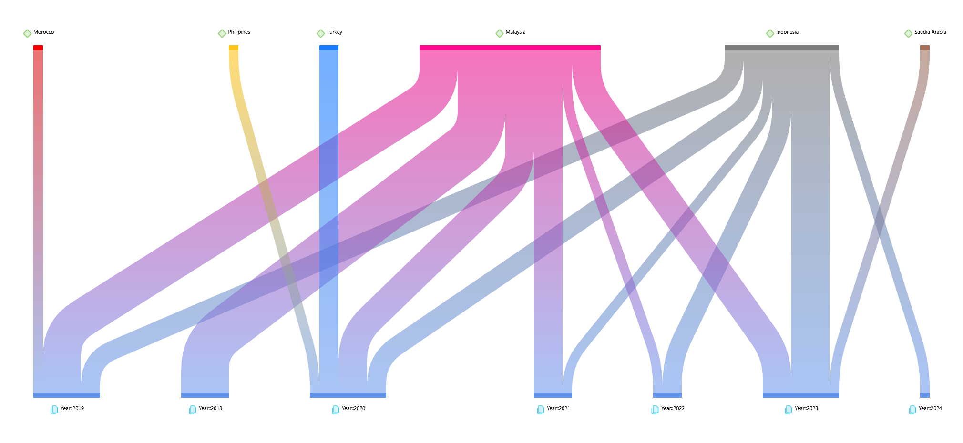

Figure 4: The Number of Articles Published Annually by Geographical Region

The world map visualisation in Figure 5 offers valuable insights into the geographical distribution of studies on waqf sustainability. It clearly illustrates that most contributions originate from the Asian region, particularly Malaysia and Indonesia, with 18 and 12 articles, respectively. Over the years, publications have fluctuated, with notable peaks in 2020 and 2023, each producing eight articles. These peaks reflect a renewed interest in waqf sustainability, likely driven by emerging challenges in governance and economic development, as well as the pressing need for innovative strategies to address these issues.

The trend also reveals a decline in publications from 2018 to 2021 before rebounding strongly in 2023. Notably, the map underscores a pressing need for greater geographical diversity in waqf-related research Importantly. Expanding research efforts to underrepresented regions could provide a broader, more inclusive perspective on the global challenges and opportunities for waqf sustainability. The consistency of output from Malaysia and Indonesia, however, highlights their critical role in driving this discourse and offers valuable models for other countries to consider.

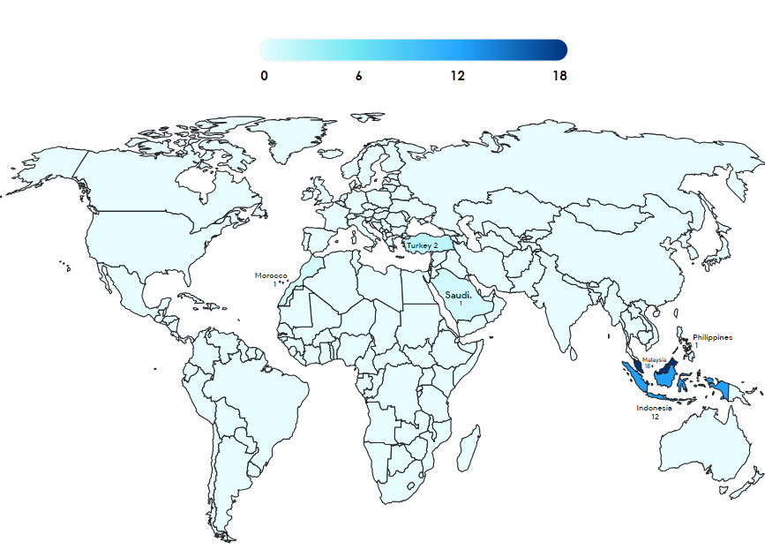

Figure 5: World Map Visualisation on Article in Waqf and Sustainability

Furthermore, the data analysis also shows the word cloud generated from the 34 articles related in Figure 6 below. The word cloud generated from 34 articles on waqf sustainability provides a compelling snapshot of the key themes and concepts frequently discussed in the literature. The prominence of "waqf" at the centre underscores its centrality to all discussions, followed by other significant terms like "management," "social," "Islamic," "financial," and "development." These words highlight the multifaceted nature of waqf, which spans religious, economic, and social domains. Terms such as "institutions," "model," and "sustainability" further suggest that much of the research revolves around exploring frameworks and mechanisms to enhance the effectiveness and longevity of waqf practices in addressing societal needs.

Interestingly, the word cloud reflects waqf sustainability's specific challenges and opportunities. Words like "governance," "resources," "human," and "accountability" indicate that improving institutional and managerial practices is a recurring focus. Meanwhile, terms such as "micro," "corporate," and "financing" suggest an emerging interest in integrating waqf with modern financial tools and entrepreneurial initiatives. Including geographical references like "Malaysia" and "Indonesia" reaffirms these nations' leading roles in waqf-related research. This visualisation underscores the need for a holistic approach that combines robust management, innovative financing models, and governance reforms to sustain waqf's impact on socio-economic development.

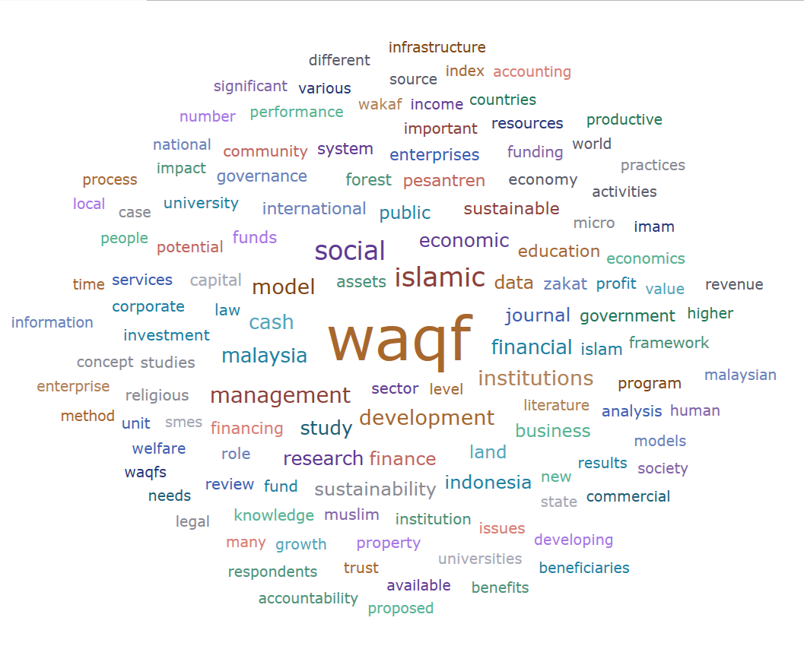

Figure 6: Word cloud generated from 34 articles

Following the above discussion, the researcher further analysed the data based on the 34 articles in Table 2 on Author vs. theme. This comprehensively categorises research articles focusing on different aspects of waqf and sustainability. There are five (5) major themes. Relating to waqf and sustainability. The themes highlight researchers' diverse approaches and topics, from Financial Sustainability and Economic Development, Community Empowerment and Social Welfare, Innovative Waqf Models and Practices, Environmental Sustainability and Waqf and Governance and Legal. The thematic analysis of waqf-related studies reveals a diverse yet interconnected exploration of sustainability challenges and opportunities. The data shows that Theme 1, Financial Sustainability and Economic Development, is the most frequently addressed, with authors such as Nik Ahmad et al. (2019), Bayram & Altarturi (2020), and Bulut (2020) contributing to this area. Their works emphasise waqf’s potential as a tool for economic resilience, focusing on financial models, innovative fundraising strategies, and cash waqf initiatives. This theme’s prominence reflects the pressing need for waqf institutions to ensure steady financial resources to maintain their impact on communities. Additionally, Theme 3: Innovative Waqf Models and Practices has gained significant attention, with authors like Sapuan & Zeni (2021) and Jannah et al. (2020) examining novel frameworks to optimise waqf operations, from advanced management practices to integrated waqf models. These studies highlight how modern tools and practices can help waqf adapt to changing social and economic landscapes.

On the other hand, Theme 2: Community Empowerment and Social Welfare also features prominently, with contributors like Mohamad Akhir et al. (2023) and Widiastuti et al. (2022) delving into how waqf initiatives can uplift communities through education, entrepreneurship, and welfare programs. This emphasis on empowerment illustrates waqf’s critical role in fostering social equity. Meanwhile, Theme 4: Environmental Sustainability and Waqf and Theme 5: Governance and Legal Framework are less represented but crucial. Authors like Jannah et al. (2024) and Huda and Santoso (2022) explore waqf’s potential in supporting green initiatives and addressing governance challenges, suggesting untapped opportunities for advancing sustainability through improved legal and institutional mechanisms. Together, these themes provide a comprehensive roadmap for enhancing waqf’s sustainability, demonstrating its multifaceted potential to drive positive change in a financial, social, and environmental context.

Table 2

*Author vs theme*

|  |  |  |  |  |  |
| --- | --- | --- | --- | --- | --- |
|  | Theme 1: Financial Sustainability and Economic Development | Theme 2: Community Empowerment and Social Welfare | Theme 3: Innovative Waqf Models and Practices | Theme 4: Environmental Sustainability and Waqf | Theme 5: Governance and Legal Framework |
| (Asiah, 2018) |  | / |  |  |  |
| (Nik Ahmad et al., 2019) | / |  |  |  |  |
| (Bayram & Altarturi, 2020) | / |  |  |  |  |
| (Razak, 2020) | / |  |  |  |  |
| (Widiastuti et al., 2022) |  |  | / |  |  |
| (Mohamad Akhir et al., 2023) |  |  | / |  |  |
| (Bulut, 2020) | / |  |  |  |  |
| (Afroz et al., 2019) |  |  |  | / |  |
| (Fauziah, 2021) | / |  |  |  |  |
| (Kusumaningtias, 2019) |  | / |  |  |  |
| (Mohd Ali et al., 2023) |  | / |  |  |  |
| (Sipan et al., 2021) |  |  |  |  | / |
| (Tahiri Jouti, 2019) |  |  | / |  |  |
| (Jannah et al., 2020) |  |  |  | / |  |
| (Laallam et al., 2020) |  |  | / |  |  |
| (Sapuan & Zeni, 2021) |  |  |  |  | / |
| (Winarsih et al., 2019) |  | / |  |  |  |
| (M. Sulaiman & Alhaji Zakari, 2019) | / |  |  |  |  |
| (Zarkasyi, 2020) |  |  | / |  |  |
| (S. Sulaiman et al., 2019) | / |  |  |  |  |
| (Robani & Salih, 2018) | / |  |  |  |  |
| (Shulthoni & Saad, 2018) | / |  |  |  |  |
| (Mohd Thas Thaker, 2018) | / |  |  |  |  |
| (Awaludin et al., 2018) |  |  |  |  | / |
| (Anas et al., 2020) |  |  |  | / |  |
| (Ibrahim et al., 2021) | / |  |  |  |  |
| (Rochani et al., 2022) |  | / |  |  |  |
| (Huda & Santoso, 2022) |  |  |  |  | / |
| (Jannah et al., 2024) |  |  |  | / |  |
| (Zawawi et al., 2023) |  |  |  |  | / |
| (Wijaya, 2023) |  |  | / |  |  |
| (Sudrajat et al., 2023) |  |  | / |  |  |
| (Laila et al., 2023) |  | / |  |  |  |
| (Raja Adnan et al., 2022) |  |  | / |  |  |

*Qualitative Reporting*

The diagram provides an overview of the comparative trends analysis of waqf practices and sustainability initiatives from 2019 to 2024. It identifies five primary themes. Theme 1, "Financial Sustainability and Economic Development," is noted 11 times, emphasising the integration of financial considerations with economic development for the sustainability of waqf. Theme 2, "Community Empowerment and Social Welfare," mentioned 6 times, highlights the significance of socially driven initiatives that empower communities to sustain waqf practices. Theme 3, "Innovative Waqf Models and Practices," noted 8 times, underscores the importance of innovation in waqf models and practices that influence sustainability. Theme 4, "Environmental Sustainability and Waqf," with 4 mentions, critically addresses the environmental aspects of waqf sustainability. Lastly, Theme 5, "Governance and Legal Framework," mentioned 5 times, reflects the importance of strengthening governance and legal frameworks to ensure the sustainability of waqf. This comprehensive analysis of themes strongly emphasises economic, social, technological, environmental, and practical management considerations within the current discourse on waqf sustainability.

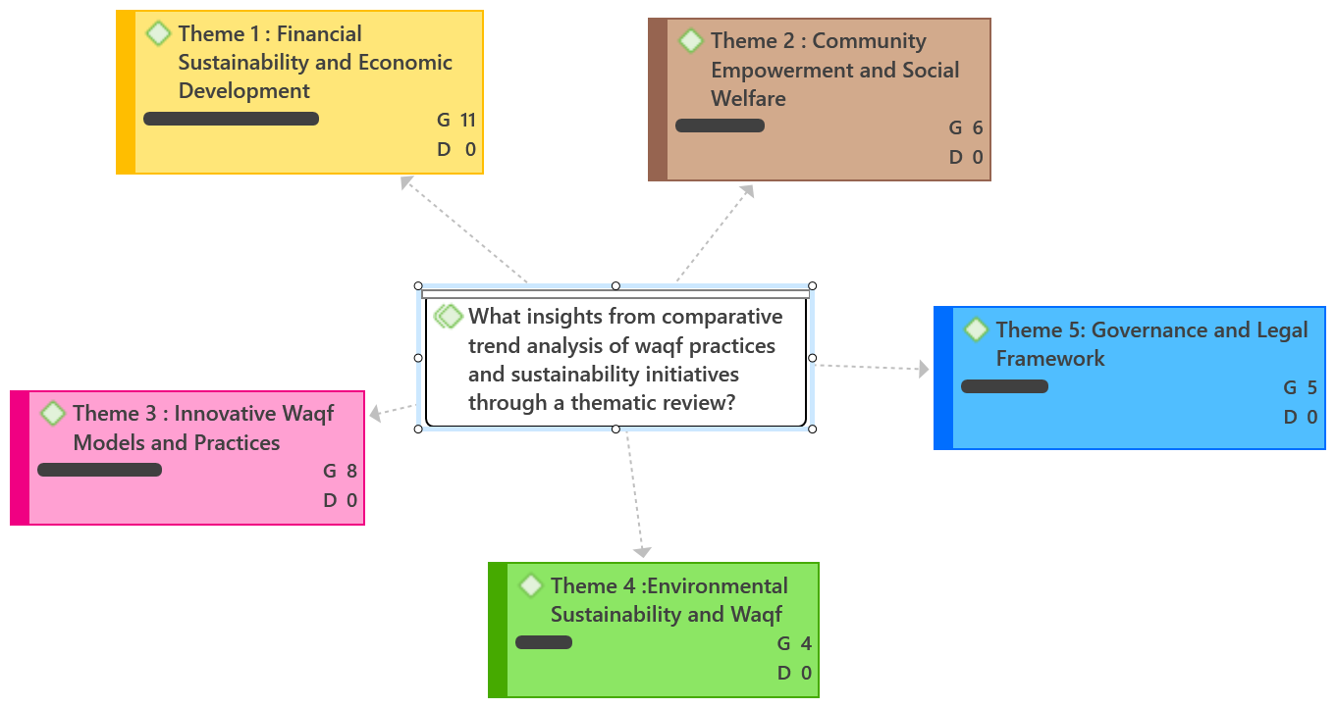

Figure 7: The Theme to Answer RQ

*Theme 1: Financial Sustainability and Economic Development*

Waqf, as an Islamic endowment, or waqf, has adapted to tackle modern financial challenges while promoting economic sustainability. Its uses now go beyond traditional charity, incorporating creative financial models designed to stimulate socio-economic growth. For instance, Nik Ahmad et al. (2019) highlight the necessity of resource optimisation and revenue diversification in securing financial sustainability within public institutions. Their research on Malaysian universities reveals that simply raising tuition fees is not a practical solution; rather, effective management of resources stands out as a crucial pathway. This viewpoint is echoed by Bayram and Altarturi (2020), who suggest a waqf-based model to assist in post-crisis reconstruction in Marawi, Philippines, intertwining historical waqf principles like debt relief to offer sustainable financial solutions. Similarly, Razak (2020) emphasises the potential role of cash waqf in Malaysia, advocating for its contribution to poverty alleviation and alignment with national economic development goals.

The historical significance of waqf further showcases its lasting importance in fostering stability and growth. For instance, the cash waqfs from the Ottoman era were instrumental in funding public welfare projects, encompassing education, healthcare, and infrastructure. This historical context illustrates waqf’s ability to meet social and economic needs over extended periods (Bulut, 2020). Building on this legacy, Fauziah (2021) introduces the Integrated Cash Waqf Social Enterprise Business (ICWSE-B) model, which combines principles of social enterprise with waqf to tackle financial challenges in Indonesia. This model aligns with the Sustainable Development Goals (SDGs) and promotes economic inclusivity by empowering marginalised communities, highlighting waqf's adaptability to current economic realities.

Effective management and innovative frameworks are essential to sustain waqf's contributions in today’s economic landscape. Ibrahim et al. (2021) advocated for integrating waqf with microfinance to bolster socio-economic development, emphasising the importance of urgency and collaboration. Additionally, Shulthoni and Saad (2018) proposed modern fundraising strategies, such as venture philanthropy and value-based capital, to strengthen waqf institutions. The financial health of waqf organisations underscores the necessity for sustainable management practices to ensure their longevity (Sulaiman & Zakari, 2019). Thus, there is a pressing need for sound administration, public awareness, and consistent funding to enhance the long-term impact of waqf initiatives (Mohd Thas Thaker, 2018). These insights collectively illustrate that with strategic innovation and management, waqf is a powerful vehicle for achieving financial sustainability and economic development. The overall argument for theme 1 is depicted in Figure 8.

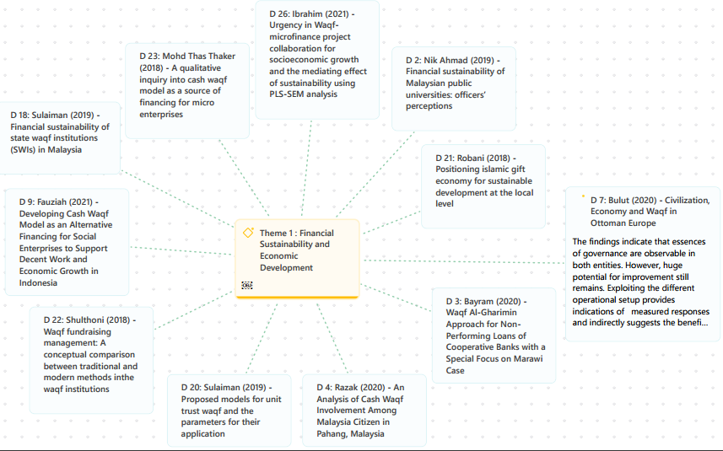

Figure 8: Theme 1: Financial Sustainability and Economic Development

*Theme 2: Community Empowerment and Social Welfare*

The diagram below outlines key themes related to community empowerment and social welfare, emphasising how Islamic principles can be utilised to address societal needs through waqf practices. Integrating waqf into family, community, and organisational settings reveals its remarkable potential for promoting social equity and well-being. Asiah (2018) points out the significance of waqf ahli in maintaining family economic stability, particularly in protecting financial security for heirs. The study underscores that family waqf safeguards assets and acts as a sustainable financial planning tool following Shari'ah. By prioritising long-term economic resilience, waqf ahli strengthens family and community empowerment, presenting a solid model for achieving economic sustainability.

Moreover, the role of waqf in social welfare shines through its capacity to tackle poverty while promoting educational and entrepreneurial growth. Kusumaningtias (2019) identifies waqf as a powerful means of poverty alleviation and social advancement, highlighting its potential to enhance education and stimulate entrepreneurship. This perspective aligns with Mohd Ali et al. (2023) research, which investigates innovative uses of cash waqf and zakat funds managed by mosques to empower asnaf communities. By combining crowdfunded waqf and zakat for sustainable agricultural projects, these initiatives illustrate how waqf can drive economic development and improve social welfare at the grassroots level. For instance, Winarsih et al. (2019) demonstrated the framework of how productive waqf supports pesantren (Islamic boarding schools), utilising integrated social and commercial economy models to ensure educational sustainability and bolster community welfare, as shown in Figure 9 in the overall theme: 2.

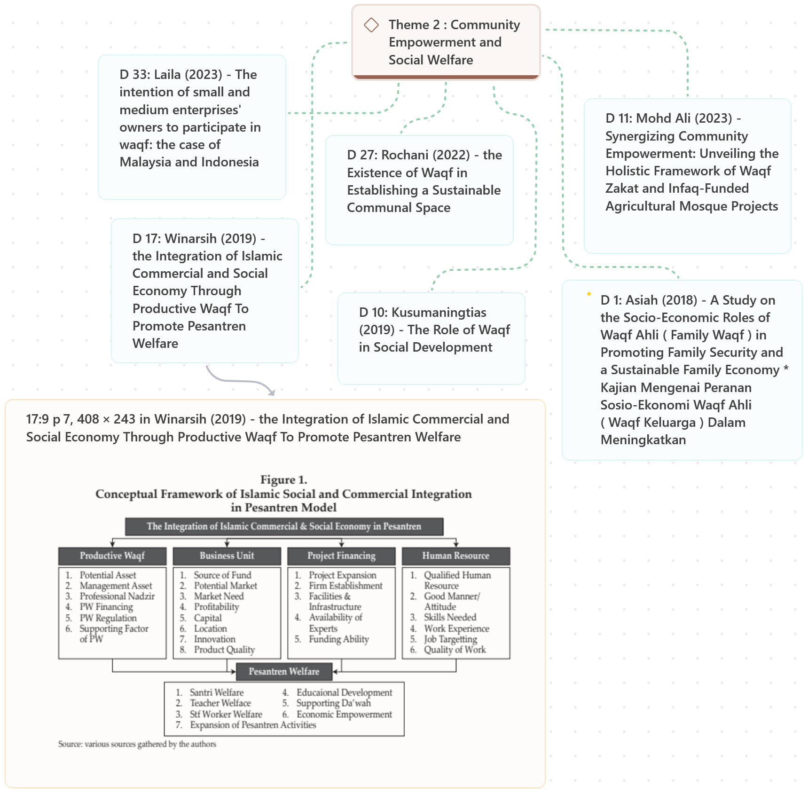

Figure 9: Theme 2: Community Empowerment and Social Welfare

Additionally, the long-term effects of waqf on community structures and its potential for modern application highlight its significance in empowering diverse groups. Rochani et al. (2022) explored how waqf can create sustainable communal spaces, showing that waqf generosity is vital in sustaining urban communities by providing shared public resources. Similarly, Laila et al. (2023) stressed the importance of engaging small and medium-sized enterprises (SMEs) in waqf initiatives. Their research indicates that increasing awareness and positive attitudes among SME owners in Malaysia and Indonesia can significantly enhance waqf participation, leading to sustainable economic systems that benefit community welfare. These themes illustrate that with effective management and strategic implementation, waqf remains essential for empowering communities and ensuring long-term social welfare.

*Theme 3: Innovative Waqf Models and Practices*

Waqf has transitioned from traditional practices to a dynamic tool for tackling contemporary socio-economic challenges. Innovative waqf models now incorporate modern financial systems, technology, and collaborative governance to ensure sustainability and maximise impact. For modern financial systems, a study by Mohamad Akhir et al. (2023) suggested integrating waqf with the ijarah instrument to address the financial constraints faced by private tahfiz schools in Malaysia. Their model demonstrates the potential of waqf-ijarah integration in establishing sustainable economic frameworks for educational institutions. Additionally, Wijaya (2023) presented the CWL-FRA (Cash Waqf Linked DINFRA) model, which combines cash waqf with infrastructure financing to bridge funding gaps in Indonesia's infrastructure sector. This model illustrates how waqf can simultaneously support economic development and national infrastructure projects, fostering a sustainable financial ecosystem.

Furthermore, technological advancements and innovative models have significantly enhanced the sustainability of waqf, amplifying its impact across various sectors. A study by Laallam et al. (2020) elaborates on this by highlighting the role of intellectual capital (IC) in addressing challenges faced by waqf institutions, such as mismanagement and a shortage of skilled labour. Their research provides a conceptual framework that emphasises how human capital and knowledge management can improve the efficiency and sustainability of waqf operations. Incorporating innovative ecosystems and intellectual capital into waqf practices has expanded its capacity to tackle social challenges. Concurrently, Tahiri Jouti (2019) proposed the importance of fostering Islamic social finance ecosystems, advocating for collaboration among various stakeholders to achieve sustainability objectives. This integrated approach ensures that social initiatives receive adequate funding and are implemented effectively.

Additionally, Raja Adnan et al. (2022) proposed a corporate waqf governance model designed explicitly for public healthcare services in Malaysia, drawing insights from historical waqf practices. Their model advocates for a public-private partnership framework that emphasises sustainability and governance to enhance the quality and accessibility of healthcare. Furthermore, they advocate for developing a comprehensive performance evaluation index for Islamic Social Finance programs, highlighting the importance of donor involvement and supervisory control as critical factors for success. Their findings illustrate how structured measurement tools can improve the sustainability of waqf-based initiatives, providing a systematic approach to assessing their impact on beneficiaries' quality of life and economic resilience (Widiastuti et al., 2022). The studies reviewed highlight how innovative waqf models effectively tackle sustainability, governance, and socio-economic development challenges, as illustrated in Figure 10.

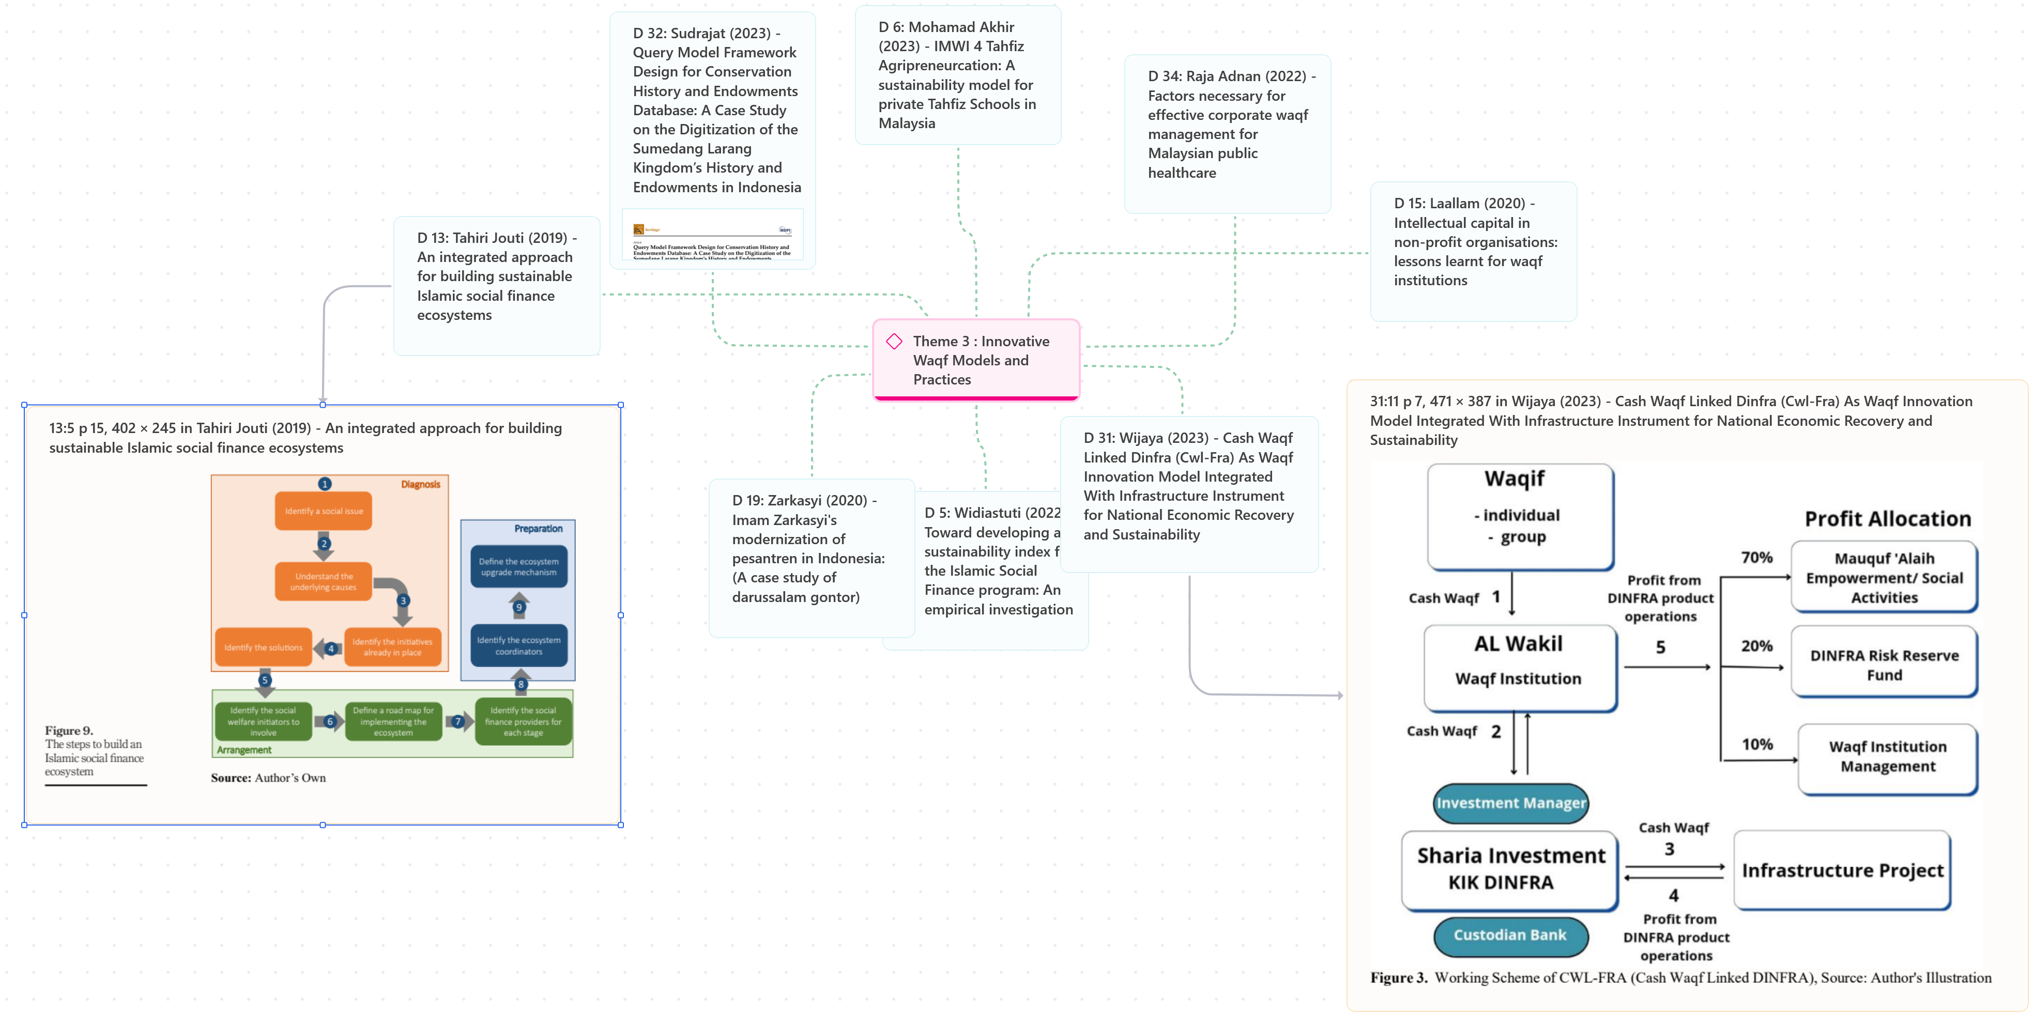

Figure 10: Theme 3: Innovative Waqf Models and Practices

*Theme 4: Environmental Sustainability and Waqf*

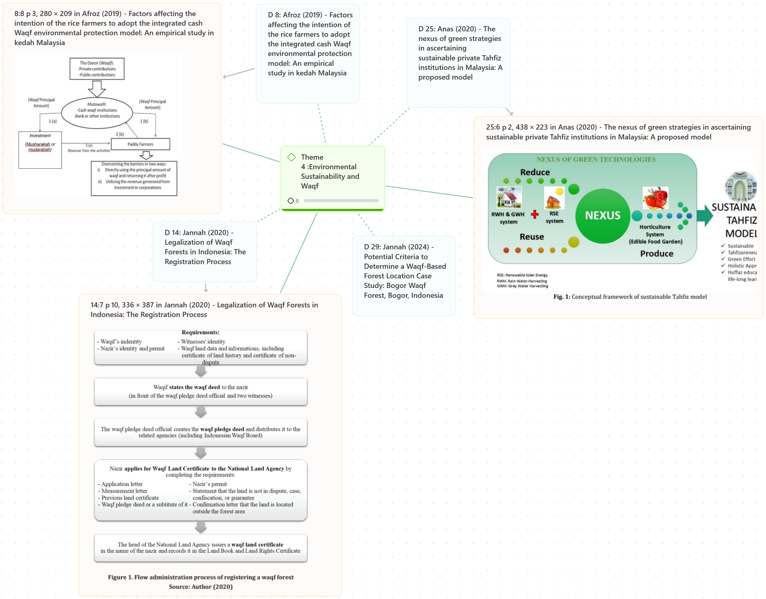

Figure 11: Theme 4: Environmental Sustainability and Waqf

The overarching themes illustrated above encapsulate the proposed framework, relating to the articles on this theme, as shown in Figure 11. This demonstrates the increasing recognition as a vital tool for promoting environmental sustainability. By incorporating ecological conservation into its framework, waqf expands its traditional role to tackle modern environmental challenges. Anas (2020) investigated the integration of green strategies in private Tahfiz institutions in Malaysia, proposing a model that combines religious endowments with ecological stewardship. This innovative approach ensures these institutions' financial sustainability and highlights their contribution to fostering ecological responsibility. Similarly, Jannah (2020, 2024) examined the legal frameworks and strategic location criteria of waqf forests in Indonesia, showcasing their potential as essential assets for environmental preservation and community resilience. These studies illustrate waqf's adaptability in supporting green initiatives, harmonising its spiritual mission with ecological goals.

The tangible impact of waqf on environmental sustainability is further demonstrated through practical applications in agriculture and grassroots contexts. Afroz (2019) presented an empirical study of rice farmers in Malaysia's Kedah region, revealing how integrated cash waqf models promote environmentally friendly farming practices. This approach not only bolsters ecological sustainability but also improves the livelihoods of local communities. Another study by Robani (2018) has enriched this discourse by exploring the role of Islamic gift economies in sustainable development at the grassroots level. His analysis emphasised waqf's potential to tackle contemporary environmental challenges while enhancing socio-economic resilience within Muslim communities. Findings from these studies affirm that, when managed innovatively, waqf can serve as a powerful mechanism for advancing ecological conservation, sustainable livelihoods, and holistic development. The intersection of waqf and environmental sustainability underscores the endowment’s ability to meet modern ecological challenges while preserving its traditional spiritual purpose. By integrating green strategies, legal frameworks, and innovative models, waqf initiatives play a significant role in fostering environmental conservation, community resilience, and sustainable development.

*Theme 5: Governance and Legal Frameworks*

Governance and legal frameworks are essential for ensuring waqf assets' sustainability and effective management. These frameworks protect the integrity of waqf operations and promote transparency, accountability, and alignment with Shariah principles. Sipan et al. (2021) addressed challenges in waqf tenancy management, particularly concerning tenancy agreements, rental determinations, and enforcement. By proposing solutions aligned with Shariah principles, this study underscores the necessity of robust governance in waqf tenancy to ensure sustainability and long-term growth. Likewise, Sapuan and Zeni (2021) employed partial least squares-structured equation modelling (PLS-SEM) to demonstrate that effective waqf management significantly impacts the sustainability of waqf institutions. Their findings highlight the importance of structured governance mechanisms in promoting the longevity and effectiveness of waqf. The figure below illustrates Theme 5: Governance and Legal Frameworks and further highlights the findings from each article within this theme.

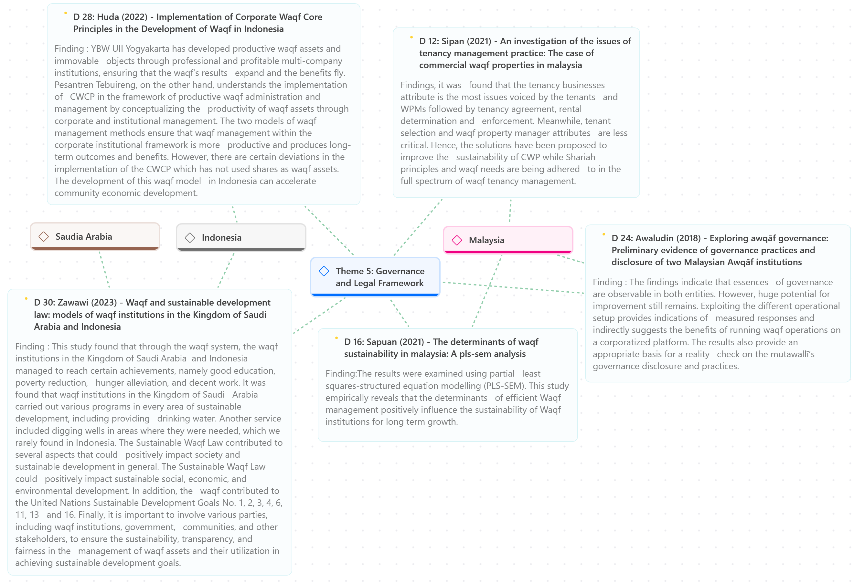

Figure 11: Theme 5: Governance and Legal Frameworks

The implementation of corporatised platforms and professional management systems further strengthens waqf governance. Awaludin et al. (2018) demonstrated that governance practices in corporatised waqf entities exhibit greater efficiency and transparency than traditional setups. The study identifies potential improvements in mutawallī (waqf trustee) governance disclosures, providing a pathway for enhancing operational effectiveness. Huda and Santoso (2022) offered complementary insights, showcasing the success of corporate waqf models in Indonesia. Through professional management of productive waqf assets, these models generate sustainable benefits and accelerate economic development. However, the study noted that implementing certain waqf models, such as those involving shares as waqf assets, requires further refinement to optimise outcomes.

Legal frameworks are integral in advancing waqf institutions toward achieving sustainable development goals. Zawawi et al. (2023) examined the Sustainable Waqf Law in Saudi Arabia and Indonesia, highlighting its contributions to education, poverty reduction, and hunger alleviation. The law has enabled waqf institutions to align with United Nations Sustainable Development Goals, particularly those related to clean water, decent work, and sustainable communities. This study underscores the importance of involving multiple stakeholders, including governments, communities, and waqf institutions, in managing waqf assets to maximise their societal impact. Integrating governance and legal frameworks in waqf management is essential for ensuring waqf operations' sustainability, transparency, and accountability. The insights highlight the need to reinforce the pivotal role of governance and legal mechanisms in advancing waqf as a tool for sustainable economic, social, and environmental development.

**Conclusion**

This thematic review has underscored the multifaceted role of waqf in promoting sustainability and addressing contemporary socio-economic and environmental challenges. Innovative models, such as cash waqf and the integration of microfinance, enhance financial sustainability while optimising resources and alleviating poverty (Nik Ahmad et al., 2019; Razak, 2020; Ibrahim et al., 2021). Historical frameworks, exemplified by the Ottoman-era cash waqf, have illustrated the waqf’s capacity for generating long-term economic impact (Bulut, 2020). Meanwhile, modern initiatives, including the Integrated Cash Waqf Social Enterprise Business model, have aligned waqf with sustainable development goals (Fauziah, 2021).

Furthermore, waqf also plays a crucial role in community empowerment and social welfare by supporting marginalised groups and enhancing family economic stability (Asiah, 2018). Initiatives within pesantren and crowdfunded waqf projects promote education and grassroots development (Winarsih et al., 2019; Mohd Ali et al., 2023). Furthermore, waqf involves small and medium-sized enterprises (SMEs), which leads to the formation of inclusive communities (Rochani et al., 2022; Laila et al., 2023).

In addition, innovative waqf models and governance frameworks broaden their impact by incorporating modern financial instruments and ensuring transparency and compliance with Shariah principles (Sipan et al., 2021; Sapuan & Zeni, 2021). The Sustainable Waqf Law further reinforces alignment with development objectives and encourages multi-stakeholder collaboration (Zawawi et al., 2023). These themes collectively illustrate that waqf is a powerful tool for advancing sustainability in contemporary society.

**Discussion and Future Studies**

The thematic review has underscored the transformative potential of waqf in tackling various sustainability challenges. Key elements such as financial sustainability and economic development are emphasised as foundational pillars. Moreover, innovative approaches like cash waqf and the integration of microfinance play a significant role in driving socio-economic growth and alleviating poverty (Nik Ahmad et al., 2019; Ibrahim et al., 2021). In terms of community empowerment and social welfare, waqf is essential in fostering inclusivity and uplifting marginalised groups (Asiah, 2018; Kusumaningtias, 2019). Creative applications, including the implementation of productive waqf in pesantren (Islamic boarding schools) and agricultural initiatives, have made a noteworthy impact at the community level (Winarsih et al., 2019; Mohd Ali et al., 2023). The potential of waqf to facilitate shared urban spaces and encourage the engagement of small and medium-sized enterprises (SMEs) within contemporary urban and entrepreneurial ecosystems also deserves further investigation (Rochani et al., 2022; Laila et al., 2023).

Despite these advancements, the situation's dynamics call for a thoughtful examination of evolving landscapes. The transformation of waqf is further propelled by innovative models and practices that adapt modern financial systems and governance mechanisms (Mohamad Akhir et al., 2023; Wijaya, 2023). In this light, developing performance indices and frameworks for intellectual capital offers valuable tools for gauging and enhancing the effectiveness of waqf initiatives (Laallam et al., 2020; Widiastuti et al., 2022). Additionally, linking waqf with environmental sustainability efforts—such as green strategies and ecological conservation—calls for further empirical research to validate its long-term impact (Anas, 2020; Jannah, 2024). Ensuring the sustainability and transparency of waqf operations hinges on strong governance and legal frameworks (Sipan et al., 2021; Zawawi et al., 2023). Lastly, investigating how governance practices, legal reforms, and stakeholder involvement interact will be critical for maximising waqf's contributions to sustainable development.

This review asserts that future research should explore scalable frameworks for integrating waqf into broader economic systems, with a special emphasis on leveraging digital platforms and the role of technology in resource optimisation. Upcoming studies should also evaluate the scalability of these models across different socio-economic landscapes and look into how artificial intelligence and blockchain technology can enhance transparency and efficiency. Together, these insights lay a solid groundwork for future research and innovation in waqf management, positioning it as a dynamic force for global sustainability. Furthermore, examining the effects of waqf on regional economic stability within diverse cultural and legal contexts could provide a more nuanced understanding of its global significance. It is equally important to quantify these initiatives' social returns and investigate cross-sector collaborations that weave waqf into public welfare policies.

**Contributions and Benefits of Study**

This thematic review significantly contributes to academia and practitioners, advancing the understanding and application of waqf in contemporary contexts. Academically, it enriches the literature by presenting a comprehensive synthesis of waqf's role in sustainability across financial, social, environmental, and governance dimensions. The study highlights innovative models such as the integration of waqf with financial systems, intellectual capital, and public-private partnerships, offering a foundation for further research into waqf’s scalability and adaptability in diverse socio-economic contexts. It also bridges gaps in knowledge regarding the intersection of waqf and environmental sustainability, shedding light on its potential to address modern ecological challenges. These insights advance theoretical frameworks and create opportunities for interdisciplinary research exploring waqf's applications in economics, law, social sciences, and environmental studies.

For practitioners, this review provides actionable insights into the management and implementation of waqf initiatives. It underscores the importance of professional governance frameworks and the incorporation of modern tools such as digital platforms and performance evaluation indices to enhance efficiency and transparency. Practitioners are offered a roadmap to harness waqf for socio-economic and environmental impact, whether through innovative models like cash waqf-linked infrastructure financing or by leveraging waqf to empower marginalised communities. Moreover, the study encourages collaboration between waqf institutions, governments, and private sectors to optimise resource utilisation and align with sustainable development goals. By bridging theory and practice, this review equips practitioners with evidence-based strategies to elevate waqf initiatives' effectiveness and societal impact in a rapidly evolving world.

**Acknowledgements**

The authors express heartfelt gratitude to Jabatan Perkhidmatan Awam (JPA), D8 Malaysia Foundation - AL-Hidayah Group, and International Islamic University Malaysia for their generous sponsorship and unwavering support throughout this study. Their contributions, both in resources and encouragement, have been instrumental in facilitating the successful completion of this work. The authors sincerely appreciate their commitment to research in waqf sustainability and their invaluable role in enabling this endeavour. We are profoundly grateful for their trust, guidance, and belief in the importance of this research.

**References**

Afroz, R., Muhibbullah, M., & Morshed, M. N. (2019). Factors affecting the intention of the rice farmers to adopt the integrated cash Waqf environmental protection model: An empirical study in kedah Malaysia. *Journal of Asian Finance, Economics and Business*, *6*(4), 189–199. https://doi.org/10.13106/jafeb.2019.vol6.no4.189

Anas, N., Ahmad, N. A., Hussain, N. H. M., Ahmad, A. C., & Yaacob, Z. (2020). The nexus of green strategies in ascertaining sustainable private Tahfiz institutions in Malaysia: A proposed model. *International Journal of Advanced and Applied Sciences*, *7*(11), 119–124. https://doi.org/10.21833/ijaas.2020.11.013

Asiah, M. N. (2018). A Study on the Socio-Economic Roles of Waqf Ahli ( Family Waqf ) in Promoting Family Security and a Sustainable Family Economy * Kajian Mengenai Peranan Sosio-Ekonomi Waqf Ahli ( Waqf Keluarga ) Dalam Meningkatkan. *IIUM Law Journal*, *26*(1), 141–160. file:///C:/Users/User/Downloads/383-Article Text-1169-4-10-20180702.pdf

Awaludin, N. S., Nahar, H. S., Yaacob, H., & Bakar, N. S. (2018). Exploring awqāf governance: Preliminary evidence of governance practices and disclosure of two Malaysian Awqāf institutions. *Journal of King Abdulaziz University, Islamic Economics*, *31*(1), 139–150. https://doi.org/10.4197/Islec.31-1.9

Bayram, K., & Altarturi, B. (2020). Waqf Al-Gharimin Approach for Non- Performing Loans of Cooperative Banks with a Special Focus on Marawi Case. *Turkish Journal of Islamic Economics*, *7*(1), 1–12. https://doi.org/10.26414/a064

Bulut, M. (2020). Civilisation, Economy and Waqf in Ottoman Europe. *Journal of Nusantara Studies (JONUS)*, *5*(2), 48–67. https://doi.org/10.24200/jonus.vol5iss2pp48-67

Fauziah, N. N. (2021). Developing Cash Waqf Model as an Alternative Financing for Social Enterprises to Support Decent Work and Economic Growth in Indonesia. *Turkish Journal of Islamic Economics*, *8*(Special Issue), 195–217. https://doi.org/10.26414/a2759

Huda, M., & Santoso, L. (2022). Implementation of Corporate Waqf Core Principles in the Development of Waqf in Indonesia. *Academic Journal of Interdisciplinary Studies*, *11*(5), 114–124. https://doi.org/10.36941/ajis-2022-0129

Ibrahim, S. S., Daud, D., Zainal, N., Noor, A. H. M., & Beik, I. (2021). Urgency in Waqf-Microfinance Project Collaboration for Socio-economic Growth and the Mediating Effect of Sustainability Using PLS-SEM Analysis. *Studies of Applied Economics*. https://doi.org/10.25115/eea.v39i10.5569

Jannah, M., Ali, K. M., Fatria, B. L., Sarkawi, A., & Othman, J. (2021). Enhancing Waqf Forest Sustainability Through Agroforestry: Case Study from Bogor Waqf Forest, Bogor, Indonesia. *Islam Realitas: Journal of Islamic and Social Studies*. https://doi.org/10.30983/islam_realitas.v7i1.4454

Jannah, M., Sarkawi, A. A., & Othman, J. (2020). Legalisation of Waqf Forests in Indonesia: The Registration Process. *Indonesia Law Review*, *10*(3), 278–293. https://doi.org/10.15742/ilrev.v10n3.629

Jannah, M., Sarkawi, A. A., & Othman, J. (2024). Potential Criteria to Determine a Waqf-Based Forest Location Case Study: Bogor Waqf Forest, Bogor, Indonesia. *Jurnal Manajemen Hutan Tropika*, *30*(1), 30–39. https://doi.org/10.7226/jtfm.30.1.30

Johari, F., Nor, F. M., Hamid, B. A., Zal, W. A. A., Ali, A. F. M., Misbah, H., Haron, H., Shahwan, S., Shafii, Z., Shaharuddin, A., Ahmad, A., Mahomed, Z., Salim, K., Yusoff, M. M., Hassan, W., & Atan, N. A. (2023). Enhancing Synergy in the Waqf Ecosystem in Malaysia: Promoting Increased Waqf Contributions Among Beneficiaries, Donors, and Mutawalli. In *International Journal of Economics and Finance Studies* (Vol. 15, Issue 3). https://doi.org/10.34109/ijefs.202315304

Kusumaningtias, R. (2019). The Role of Waqf in Social Development. *KnE Social Sciences*, *3*(11), 348. https://doi.org/10.18502/kss.v3i11.4018

Laallam, A., Kassim, S., Engku Ali, E. R. A., & Saiti, B. (2020). Intellectual capital in non-profit organisations: lessons learnt for waqf institutions. *ISRA International Journal of Islamic Finance*, *12*(1), 27–48. https://doi.org/10.1108/IJIF-10-2018-0111

Laila, N., Ratnasari, R. T., Ismail, S., Mohd Hidzir, P. A., & Mahphoth, M. H. (2023). The intention of small and medium enterprises’ owners to participate in waqf: the case of Malaysia and Indonesia. *International Journal of Islamic and Middle Eastern Finance and Management*, *16*(3), 429–447. https://doi.org/10.1108/IMEFM-01-2022-0014

Mohamad Akhir, N. S., Mohd Yusof, A. S., Hussin, R., & Mohammed Ghazali, A. (2023). IMWI 4 Tahfiz Agripreneurcation: A sustainability model for private Tahfiz Schools in Malaysia. *Environment-Behaviour Proceedings Journal*, *8*(SI14), 59–64. https://doi.org/10.21834/e-bpj.v8isi14.5057

Mohd Ali, S. N., Arshad, H., Fauzi, N. S., & Ghonim, S. M. A. A. (2023). Synergizing Community Empowerment: Unveiling the Holistic Framework of Waqf Zakat and Infaq-Funded Agricultural Mosque Projects. *Environment-Behaviour Proceedings Journal*, *8*(26), 131–136. https://doi.org/10.21834/e-bpj.v8i26.5146

Mohd Thas Thaker, M. A. Bin. (2018). A qualitative inquiry into cash waqf model as a source of financing for micro enterprises. *ISRA International Journal of Islamic Finance*, *10*(1), 19–35. https://doi.org/10.1108/ijif-07-2017-0013

Nik Ahmad, N. N., Ismail, S., & Siraj, S. A. (2019). Financial sustainability of Malaysian public universities: officers’ perceptions. *International Journal of Educational Management*, *33*(2), 317–334. https://doi.org/10.1108/IJEM-06-2017-0140

Raja Adnan, R. A. binti, Abdul Mutalib, M., & Ab Aziz, M. R. (2022). Factors necessary for effective corporate waqf management for Malaysian public healthcare. *ISRA International Journal of Islamic Finance*, *14*(1), 73–88. https://doi.org/10.1108/IJIF-11-2019-0178

Razak, S. F. F. B. A. (2020). *An Analysis of Cash Waqf Involvement Among Malaysia Citizen in Pahang, Malaysia*. 388–395. https://doi.org/10.15405/epsbs.2020.12.05.41

Robani, A., & Salih, K. (2018). Positioning islamic gift economy for sustainable development at the local level. *Humanities and Social Sciences Reviews*, *6*(2), 111–120. https://doi.org/10.18510/hssr.2018.6214

Rochani, A., Yuliastuti, N., & Sudarwanto, B. (2022). the Existence of Waqf in Establishing a Sustainable Communal Space. *Journal of Islamic Architecture*, *7*(1), 57–66. https://doi.org/10.18860/jia.v7i1.15310

Sapuan, N. M., & Zeni, N. A. M. (2021). The determinants of waqf sustainability in malaysia: A pls-sem analysis. *International Journal of Business and Society*, *22*(1), 102–118. https://doi.org/10.33736/IJBS.3164.2021

Shulthoni, S. and. (2018). Waqf fundraising management: a conceptual comparison between traditional and modern methods in the waqf institutions. In *Indonesian Journal of Islam and Muslim Societies* (Vol. 8, Issue 1). https://doi.org/10.18326/ijims.v8i1.57-86

Sipan, I., Abas, F. N., Ghazali, N. A., & Yaacob, A. C. (2021). An investigation of the issues of tenancy management practice: The case of commercial waqf properties in malaysia. *Planning Malaysia*, *19*(3), 283–294. https://doi.org/10.21837/PM.V19I17.1006

Sudrajat, R., Ruchjana, B. N., Abdullah, A. S., & Budiarto, R. (2023). Query Model Framework Design for Conservation History and Endowments Database: A Case Study on the Digitization of the Sumedang Larang Kingdom’s History and Endowments in Indonesia. *Heritage*, *6*(12), 7508–7530. https://doi.org/10.3390/heritage6120394

Sulaiman, M., & Alhaji Zakari, M. (2019). Financial sustainability of state waqf institutions (SWIs) in Malaysia. *Journal of Islamic Accounting and Business Research*, *10*(2), 236–258. https://doi.org/10.1108/JIABR-05-2016-0054

Sulaiman, S., Hasan, A., Mohd Noor, A., Ismail, M. I., & Noordin, N. H. (2019). Proposed models for unit trust waqf and the parameters for their application. *ISRA International Journal of Islamic Finance*, *11*(1), 62–81. https://doi.org/10.1108/IJIF-02-2018-0019

Tahiri Jouti, A. (2019). An integrated approach for building sustainable Islamic social finance ecosystems. *ISRA International Journal of Islamic Finance*, *11*(2), 246–266. https://doi.org/10.1108/IJIF-10-2018-0118

Widiastuti, T., Prasetyo, A., Robani, A., Mawardi, I., Rosida, R., & Al Mustofa, M. U. (2022). Toward developing a sustainability index for the Islamic Social Finance program: An empirical investigation. *PLoS ONE*, *17*(11 November), 1–26. https://doi.org/10.1371/journal.pone.0276876

Wijaya, R. P. (2023). Cash Waqf Linked Dinfra (Cwl-Fra) As Waqf Innovation Model Integrated With Infrastructure Instrument for National Economic Recovery and Sustainability. *Malaysian Journal of Syariah and Law*, *11*(2), 330–343. https://doi.org/10.33102/mjsl.vol11no2.422

Winarsih, R., Masrifah, A. R., & Umam, K. (2019). the Integration of Islamic Commercial and Social Economy Through Productive Waqf To Promote Pesantren Welfare. *Journal of Islamic Monetary Economics and Finance*, *5*(2), 321–340. https://doi.org/10.21098/jimf.v5i2.1065

Zairul, M. (2021a). A thematic Review on Industrialised Building System (IBS) Publications from 2015-2019: Analysis of Patterns and Trends for Future Studies of IBS in Malaysia. *Pertanika Journal of Social Sciences and Humanities*, *29*(1), 635–652. https://doi.org/10.47836/pjssh.29.1.35

Zairul, M. (2021b). Opening the Pandora Box of Issues in the Industrialized Building System in Malaysia : A Thematic Review. *Journal of Applied Science and Engineering*, *25*, 297–310. https://doi.org/10.6180/jase.202204_25(2).0006 1.

Zairul, M. (2023). *Thematic Review template* (Patent No. CRLY2023W02032). Controller of Copyright.

Zairul, M., Azli, M., & Azlan, A. (2023). Defying tradition or maintaining the status quo? Moving towards a new hybrid architecture studio education to support blended learning post-COVID-19. *Archnet-IJAR: International Journal of Architectural Research*. https://doi.org/10.1108/ARCH-11-2022-0251

Zairul, M., & Mohd Zairul. (2020). A THEMATIC REVIEW ON STUDENT-CENTRED LEARNING IN THE STUDIO EDUCATION. *Journal of Critical Reviews*, *7*(02), 504–511. https://doi.org/10.31838/jcr.07.02.95

Zarkasyi, H. F. (2020). Imam Zarkasyi’s modernization of pesantren in Indonesia: (A case study of darussalam gontor). *Qudus International Journal of Islamic Studies*, *8*(1), 161–200. https://doi.org/10.21043/QIJIS.V8I1.5760

Zawawi, Z., Yasin, Y., Helmy, M., Ma’yuf, A., & Arwani, A. (2023). Waqf and sustainable development law: models of waqf institutions in the Kingdom of Saudi Arabia and Indonesia. *Ijtihad : Jurnal Wacana Hukum Islam Dan Kemanusiaan*. https://doi.org/10.18326/ijtihad.v23i1.93-114